DVT-FPPNN High Fidelity Two Probe Kit

40/50/70/110 GHz Wide Pitch True Differential PCB-Based TDR/VNA Probes

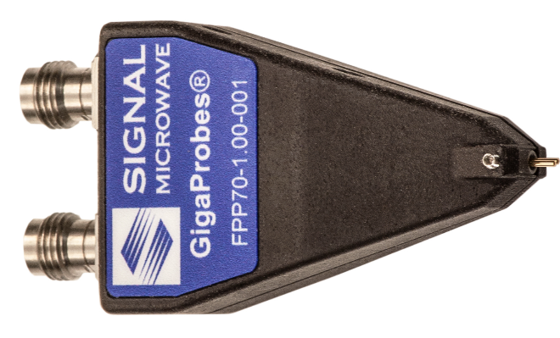
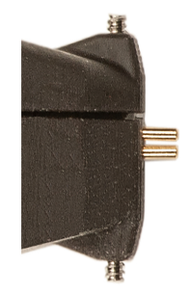
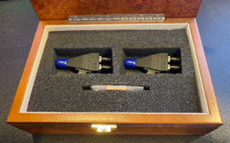
Enlarged side view of probe tips

Part Numbers

DVT-FPP40, DC-40 GHz Differential Probe

DVT-FPP50, DC-50 GHz Differential Probe

DVT-FPP67, DC-70 GHz Differential Probe

DVT-FPP110, DC-110 GHz Differential Probe

US Patents 10852322, 11175311 (Other pats pend)
Instrument Compatibility

TDR, VNA and BERT Scope Instruments
Applications

Measuring Final PCB Prototype Designs against specs

Differential impedance, S-Parameter bandwidth wide-pitch measurements up to 110 GHz

90 GHz Nyquist S-parameter Analysis of PAM6 Designs at 448 Gbps

Electrical Characteristics

Differential Probe Connectors/Frequency

Ranges: 40 GHz /2.92 mm, 50 GHz /2.4 mm, 70 GHz/1.85 mm and 110 GHz/1.0 mm

Linear Roll-off Frequency Response

Tightly Coupled Fully Balanced Differential Probes

No Ground Contact Probe Tips

Measures: True Differential S-parameters

100 Ohm (nominal) Differential Impedance
Mechanical Characteristics

Differential controlled-impedance PCB-Based Design

Fixed Pitches: 1 mm (1000 um), .8 mm (800 um),

.6 mm (600 um), to 0.35 with offset probing

A .6 mm probe can cover 0.35 to 1 mm test pad pitches.

Rugged Flex-Steel beryllium Probe Tips

Fixed Pitch Signal-to-Signal Probe Tips

No Ground Pin Required

Included 2-Axis Adapters used for mounting Probe Positioners (+/- 90 °)
Probe De-Embedding

Probe de-embedding files are included

Each de-embedding file has the serial number of the associated probe
Service and Support

Industry’s Only 1 Year Unconditional Warranty

Replacement Repair Service

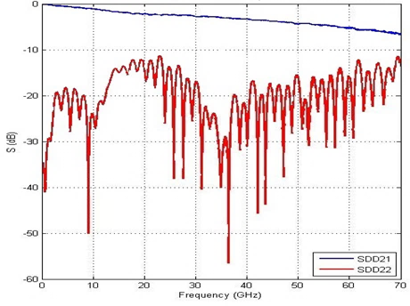

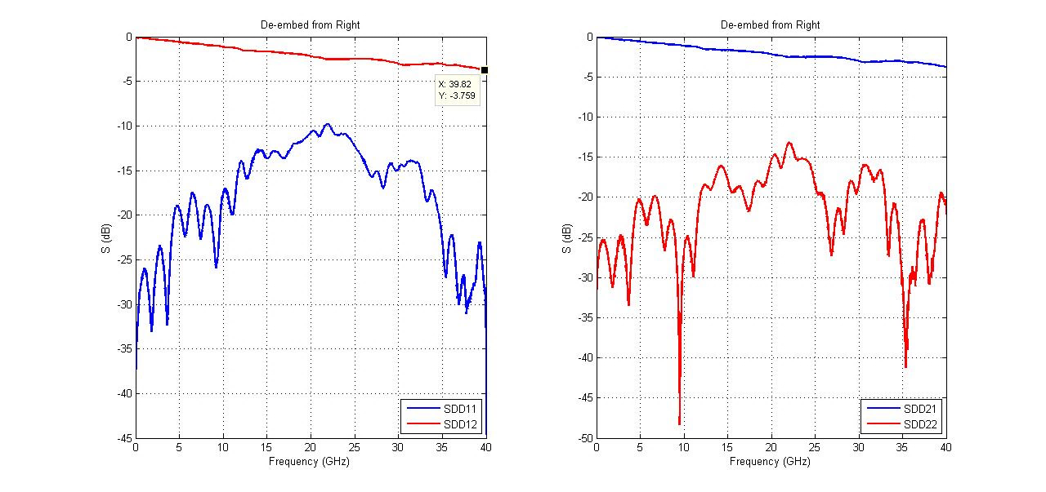

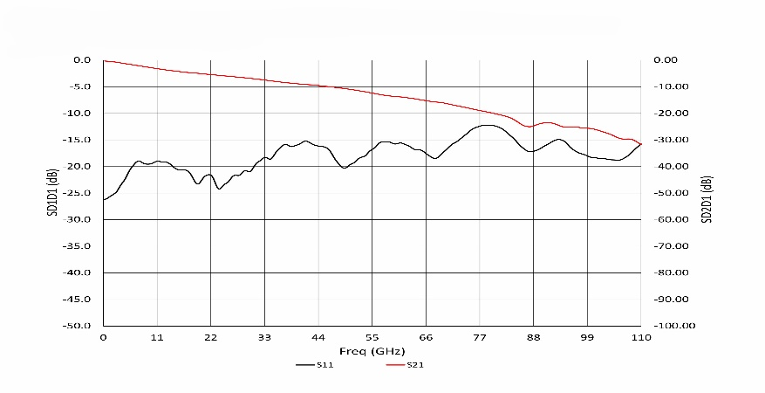
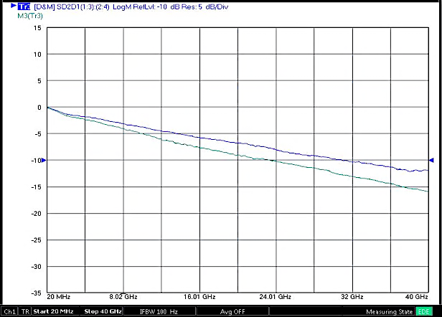
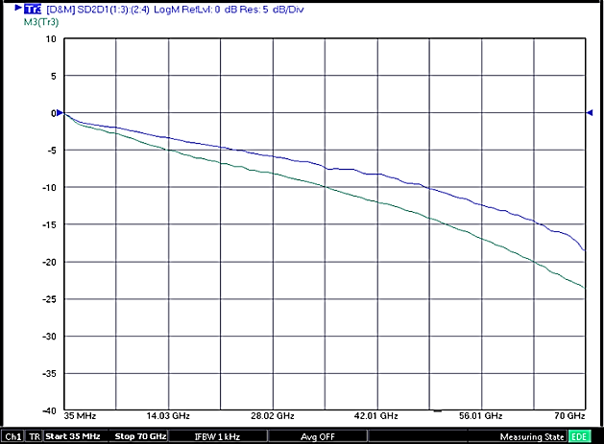
Insertion loss measurement with probe de-embedded
Insertion loss measurement with no probe de-embedded
Insertion loss measurement with probe de-embedded
Insertion loss measurement with no probe de-embedded

(On right) Raw bandwidth specs for the 40 to 110 GHz differential probes.
These SDD21/11 differential probe bandwidth plots are generated using actual “thru” measurements with the Signal–Signal probe tips set to 1 mm and no de-embedding applied (110 GHz probe tested at .8 mm pitch).

Architecture Comparison
True Differential PCB-Based vs. Wire-Based SS Probe
Probe architecture directly affects differential SI measurement accuracy

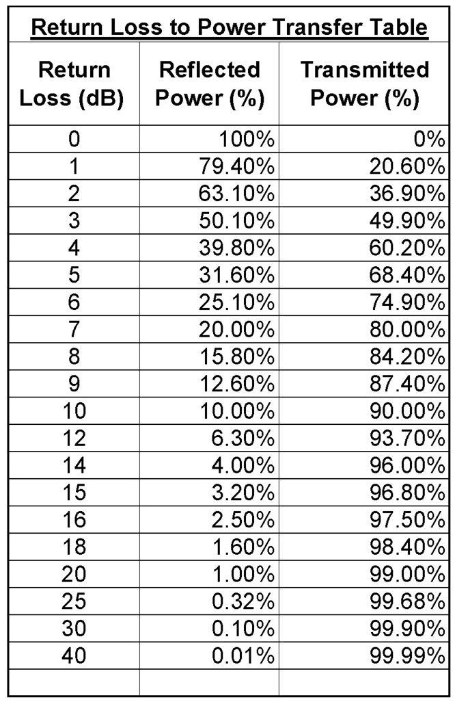
A wire-based SS probe can measure differential signals, but a PCB-Based
DVT-FPPNN probe is designed to preserve differential signal fidelity.
PCB-based probes
−10dB/-17 dB return loss (typical of DVT-FPPNN probes) corresponds to ~98% power delivered (~2% reflected), indicating very high transmission efficiency.
Wire-based probes
−4 to −5 dB return loss corresponds to ~60–68% power delivered (~32–40% reflected energy), resulting in significantly reduced measurement fidelity compared to higher-return-loss PCB-based probes.
DVT-FPPNN PCB-Based SS Probes
Wire-Based SS Probes
- Datasheet: SS differential probe, 50 ± 2 Ω input
- Architecture: Two separate internal conductors with internal ground/shield reference
- Electrical behavior: Two 50 Ω single-ended paths
- Not a true 100 Ω balanced differential structure
- Time domain: poor to significant mismatch impedance reflections at probe tips
- Frequency domain: Insertion-loss contains standing wave ripple which lowers return loss (~4dB) measurements
- VNA Measurements: Odd-mode S-Parameters
- Probe de-embedding file: Often not included, requiring additional software, a 2xThru board, and extra customer time to create them.
- Probe tips: fixed pitch, one probe may be required for each unique test pad pitch, increasing cost and setup time, no warranty
- Datasheet: True differential 100 Ω input impedance
- Architecture: Tightly coupled, fully balanced internal PCB differential trace
- Electrical behavior: One controlled true differential transmission structure
- Time domain: No mismatch Impedance reflections
- Frequency domain: Linear insertion loss, no standing wave ripple, High return loss (-10dB/-17dB)
- VNA Measurements: Odd mode S-Parameters
- Probe de-embedding file: Included with probe, no extra software required
- Unique probe tips design: Flex Steel, 1 Yr unconditional warranty, one 0.6 mm DVT-FPPNN probe can contact >10 differential test pad pitches from 0.35 mm to 1.0 mm for complete prototype PCB characterization without multiple fixed-pitch probes.
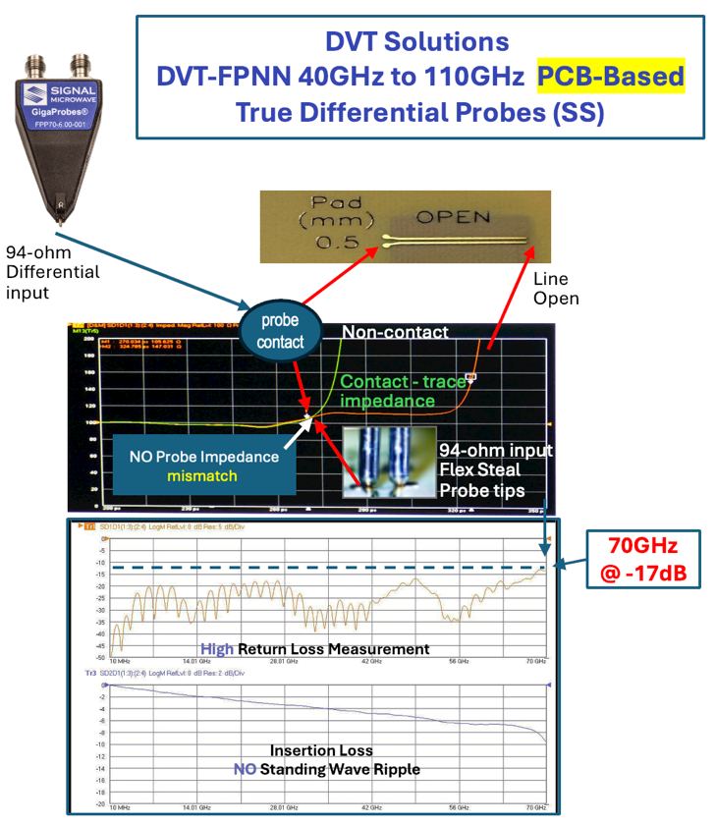

Differential Probe Architectures
PCB-Based Probes vs Wire-Based Probes
Impact of Probe Design on S-Parameter Measurement Accuracy

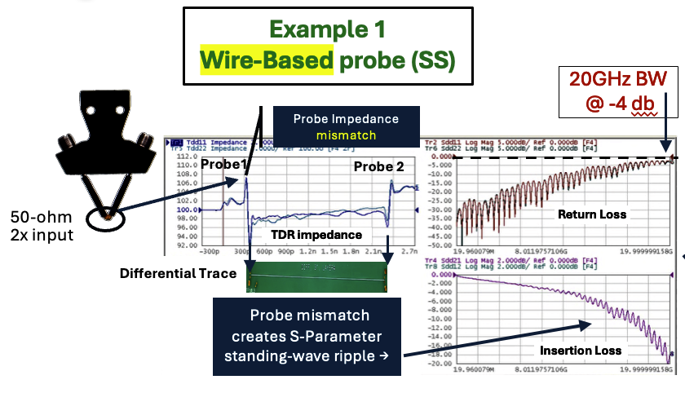
Wire-Based probe Manufacturers
GGB, ind., Form Factor, MPI, Giga Test, Keysight, and more..

(-17dB )
DVT-FPP70 70GHz
PCB-based differential
100-ohm input probe impedance

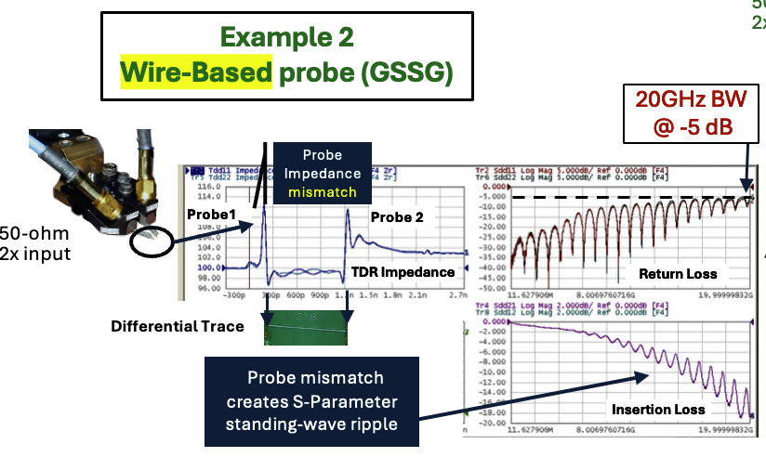

DVT-FPPNN PCB-Based probes reveals more of the DUT’s True Signal Integrity Performance

Building a Desktop Dual Time & Frequency Domain Measurement System

To configure a dual desktop probe system

Connect two DVT-FPPNN probes to the end of the probe arm of each DVT-FP250 Probe Positioner.

Depending on the size of the board, use one or two DVT-CS-3 or DVT-CS-1 cameras to verify the probes contacting the probe pads (as small as <20 mils in diameter) and to planarize the probe tips to the test pads. Each USB camera probe image is displayed using its utility software on a PC display to verify that both probes are making contact at the same time. Using two cameras vastly reduces setup times compared to using one camera and repositioning the camera each time you move the probes to a different probing location.

For horizontal probing, use four DVT-SM Holders to secure the corners of your PCB to keep it from moving while probing. You can also remove a segment from two of the holders and place them under the PCB near where it will be probed to keep the board from bowing (At least 6 holders recommended).
For vertical probing, contact us for custom configurations.

Probe System Components
DVT-FP100-1IN, DVT-FP100-1.5IN and DVT-FP100-2IN Stackable 1", 1.5" and 2" magnetic blocks used to raise the probe and camera positioners to clear the test board.

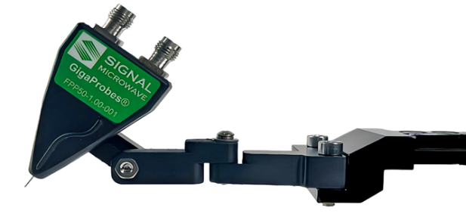
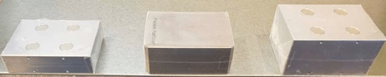
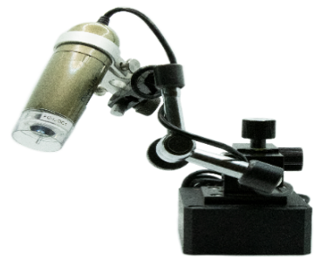
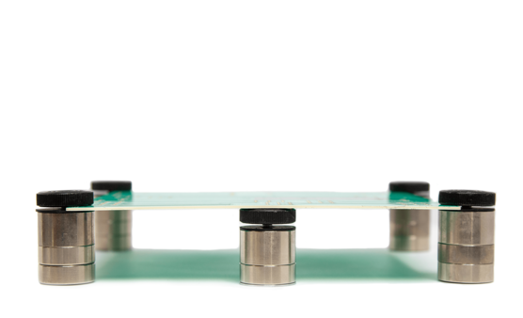
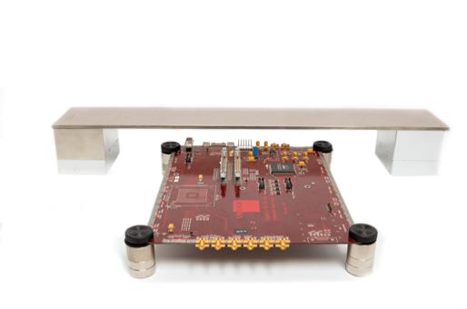
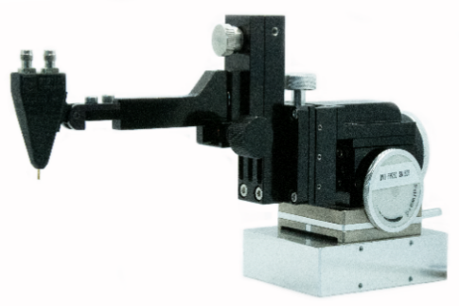

DVT-FP100 Magnetic Bases
DVT-FP100-1IN, DVT-FP100-1.5IN and DVT-FP100-2IN Stackable 1", 1.5" and 2" magnetic blocks used to raise the probe and camera positioners to clear the test board.

DVT-FPP67 70 GHz Differential

Dual Probe Kit
70 GHz Dual Probe Differential TDR and S-Parameters Probe kit. Contains two fixed differential probes. Includes a copper shorting block for creating probe models.

Rigid arm probe manipulator with XYZ pitch 40 TPI controls & magnetic base. Recommended for probing with DVT40 and DVT-FPPXX probes.

This adapter, for the DVT-FPPNN probes only, improves ease and efficiency in probing vertical and horizontal PCBs on tight-pitched test pads and when complex angles are required.

2-Axis Probe Adapter

DVT-SM Holders
Stackable Magnetic PCB Holders on the corners of a PCB keep it from moving while probing. Also, remove a segment from two holders placing them under the PCB near where it will be probed to keep the board from bowing (6+ holders recommended).

A Versatile bridge with magnetic base for probing applications which extends the probe reach to enable probing of larger boards.

DVT-PB100-24 Probe Bridge
The Camera System is used for the accurate placement of probe tips on the test pads, probe tip planarization and calibration.

DVT-CS-1 Camera System

DVT-FP250 Probe Positioner

